Workshop Registration Fall 2023

PLEASE PRINT

Name: ____________________________________________________

City State Zip:_______________________________________________

Phone: ❑ Cell ❑ Home ❑ Work:________________________________

Email: _____________________________________________________

Website: ____________________________________________________

❑ September 23 – White Line Woodcut Printmaking with Sharon Estes
9:00 AM – 3:00 PM

$90 Member/$100 Non-Member -mandatory materials fee $30

❑ Date TBA: Portrait Painting – Bill Gallagher
9:00 AM – 3:00 PM
$90 Member/ $100 Non-Member

Questions to info@eastgreenwichartclub.org

Please make a copy for your record

Please make check payable to East Greenwich Art Club, and mail to:
East Greenwich Art Club • PO Box 1608, East Greenwich, RI 02818

White Line Woodcut Printmaking
Instructor: Sharon Estes

This class will take students through the history of white line woodcut, widely considered the sole American woodcut technique, to basic carving skills, painting techniques, and making prints. By the end of the class, students will have a good understanding of basic white line woodcut printmaking, and will be introduced to more advanced techniques if time allows.
Material List to be provided. Cost $30

Instructor: Sharon Estes
Saturday, September 23, 2023
Location: East Greenwich Recreation Building, 1127 Frenchtown Road
9:00am-3:00 PM
$90 member/ $100 nonmember

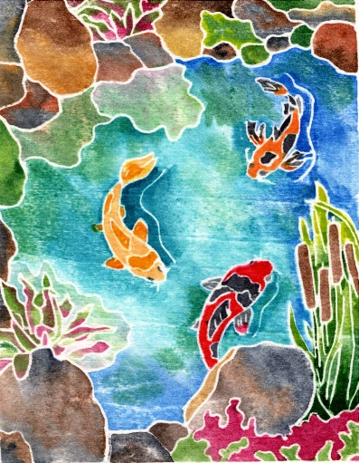 | 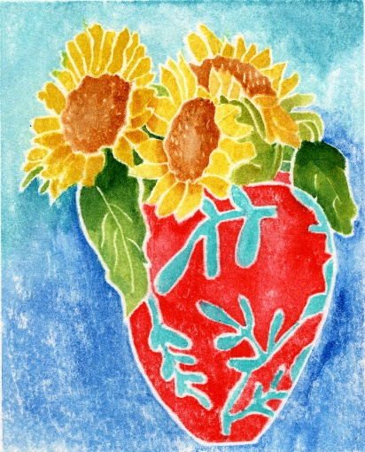

Portrait Painting with Bill Gallagher

This class will show techniques used in fashion design and portraiture, using ink wash and watercolor techniques. The practice uses different techniques from using the two mediums purely. Some work will be done with Prismacolor pencils under and over the washes.

Instructor: Bill Gallagher
Saturday October 21, 2023
Location: East Greenwich Recreation Building, 1127 Frenchtown Road
9:00am-3:00pm
$90 member/$100 nonmember

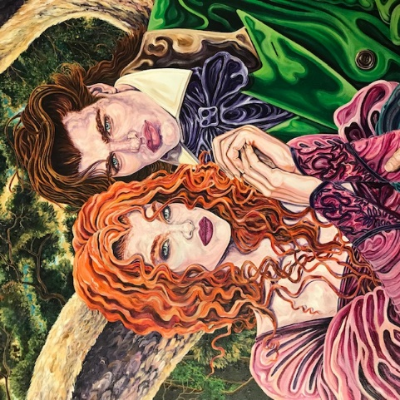 | 