Workshop Registration Spring 2023

PLEASE PRINT

Name: ____________________________________________________

City State Zip:_______________________________________________

Phone: ❑ Cell ❑ Home ❑ Work:________________________________

Email: _____________________________________________________

Website: ____________________________________________________

❑ March 25: Watercolor Techniques -- Frances Topping
9:00 AM – 1:00 PM

$60 Member/$70 Non-Member -optional materials fee TBA

❑ April 15: Drawing Birds Nests-- Ann Bianchi
9:00 AM – 1:20 PM

$60 Member/$70 Non-Member -optional materials fee $8

❑ May 13 and May 20: Painting in Layers -- Dan Lake
9:00 AM – 1:00 PM
$90 Member/ $100 Non-Member -materials provided for first class

Questions to info@eastgreenwichartclub.org

Please make a copy for your record

Please make check payable to East Greenwich Art Club, and mail to:
East Greenwich Art Club • PO Box 1608, East Greenwich, RI 02818

Watercolor – The Most Amazing Medium

Easy steps to mastering the medium
Through demonstration and individual practice and attention we will have fun exploring different
techniques. How and when to use are key to mastery whether you aspire to botanical works,
landscapes, looser florals or imaginative works. Everyone has their own style. It does take
practice. Have fun exploring wet in wet and color mixing or dry brush detail as well as lifting,
correcting mistakes, washes and glazing, negative painting and surprising happenings which
are all part of watercolor painting. Let’s begin, get creative and enjoy this amazing medium.
Materials will follow on registration either supplied with a fee or bring your own.

Instructor: Frances Topping
Saturday, March 25
Location: East Greenwich Recreation Building, 1127 Frenchtown Road
9:00am-1:00pm
$60 member/$70 nonmember
Materials fee to be determined

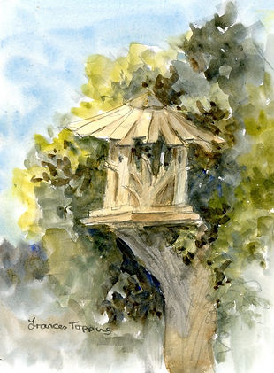 | 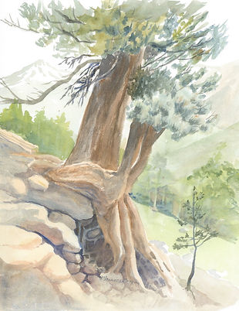

Spring Nests with Ann Bianchi

Bird’s nests and eggs highlight new life, weavings, and soothing oval subjects. A welcome to spring! They build and create their nests as an artist creates a work of art…carefully, not perfect, but with attention to details and each one an original! Surprise objects are often woven between the sticks and twigs, the bird’s signature.
Choose your favorite drawing or painting materials and join us for this exciting “Spring Nests” workshop. Create with your favorite materials, or try new ones while enjoying perspective, depth, value, and highlights in your work. Ann will share information, demonstrations, and guidance to draw nests and eggs with limited or full color, in natural or contemporary hues. To begin the workshop, we’ll first practice together in pencil, choose our photos or subjects, and create! Bring supplies including practice paper(suggested 8 x 10 or 9x11 or 10 x 10), firm surfaces to create on, and any materials you will need or a material fee of $8 if you want the workshop to provide supplies.

Material Suggestions: Graphite Pencils, Colored Pencils, Oil Pastels, Acrylics, or mixed media.
Visual reference of a nest is helpful. Ann will also provide many and some actual nests.

Instructor: Ann E. Bianchi
Saturday, April 15
Location: East Greenwich Recreation Building, 1127 Frenchtown Road
9:00am-1:30pm
$60 member/ $70 nonmember

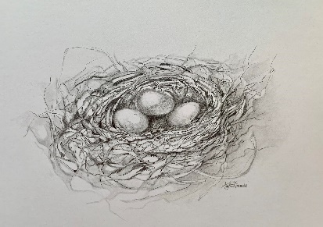 | 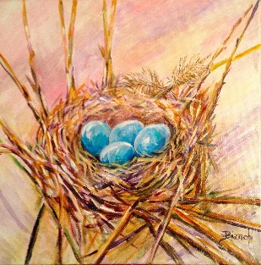

Painting in Layers- the Grisaille Technique

Many of the masters of oil painting used a method that involved multiple layers of paint done over time. We will investigate that process by doing a simplified version of their techniques! During the first session Dan will guide you as you compose and underpaint a gessoed panel with burnt umber and titanium white ACRYLIC paint. During session two you will overpaint the first work with OIL paints. Use your own photos as inspiration. Panel and acrylic paint to be provided for session 1, bring your own oils for session 2.

For students with some experience using oil paints.
Instructor: Dan Lake
2 Saturdays, May 13 and May 20
Location: East Greenwich Recreation Building, 1127 Frenchtown Road
9:00am-1:00pm
$90 member/$100 nonmember

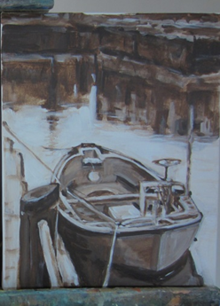 | 